**Project Report: Undernourishment**

# **Introduction**

Undernourishment is a state, lasting for at least one year, of inability to acquire enough food, defined as a level of food intake insufficient to meet dietary energy requirements. The consequence of undernourishment is called undernutrition. The US FAO (Food and Agriculture Organization) named four outcomes of undernourishment, and/or poor absorption, and/or poor biological use of nutrients consumed as a result of repeated infectious disease. These outcomes include the following:

* Being underweight for one’s age
* Underweight is defined as low weight for age in children, and BMI of less than 18.5 in adults
* For children, two consequences of undernourishment include-
* Being ‘too short for one’s age’ which is called stunting
* Being ‘dangerously thin for one’s height’ which is called wasting
* Being ‘deficient in vitamins and minerals’ which is called ‘micronutrient malnutrition’

This study includes the undernourishment percentages across different countries between 2000- 2017. This study discusses about the following issues-

1. How has the undernourishment changed in countries over time?
2. How can we tackle undernourishment?

As per my initial proposal, I conducted an analysis as to how undernourishment affects the world at large. Besides, I also found undernourishment patterns in specific countries/regions and studied what steps have been most successful to tackle undernourishment in the most affected countries.

**Methodology**

There were different data sets within food deficit, undernourishment, and child stunting, hence, there was a need of data restructuring in order to make full use of the time component of the data for each country. The data for each country was listed in columns by year, and thus required these columns to be pivoted/transposed so that the years or date value would become a variable in itself. From there, the year variable’s data type had to be changed to a date data type.

I used the data from Our World in Data (OWID) to figure out how food deficit and undernourishment has prevailed for several years, and how it has changed in various countries over a particular time period. I did a time series analysis to observe any trends related to this in different countries. I also did an analysis to find out which countries were most affected on an average throughout the years.

I faced few challenges, particularly with the data and with developing the flow of story. Primarily with the data I faced the issue of countries not reporting their information to the United Nations, those particular countries from the list had to be removed. Additionally, there were some countries that had gaps within their reporting, so parts of the analysis failed to show whole pictures. However, the issue was resolved focusing more on the world values and comparing it to specific countries that seemed to suffer the most.

The other challenge I faced was developing a storyline that made sense and would come around full picture. My story is multifaceted in the sense that it contains 3 overarching themes including: food deficit, undernourishment, and child stunting. Also, there were 2 views level that were being examined, the world view and specific country views. So, with all these layers, it was important to determine an important order. I managed to tackle the challenge by first starting off with the world view approach and then funneling it down to examine each of the three top 3 countries. So, this would ultimately add up to four sections, and then each of these sections contained a review of the current food deficit, undernourishment, and child stunting status at each of the levels. Additionally, food deficit was made to come before undernourishment, and undernourishment before child stunting. This approach was selected because one impacts the other in that order following the concept, “Food deficit can lead to Undernourishment, which may lead to Child Stunting,”.

# **Analysis**

1. I started the study with the initial question- determining the impact of undernourishment at the world level. I figured out that there were two levels to the problem- food deficit (the non-availability of food), and undernourishment (the non-distribution of food, which might be result of the non-availability in itself).

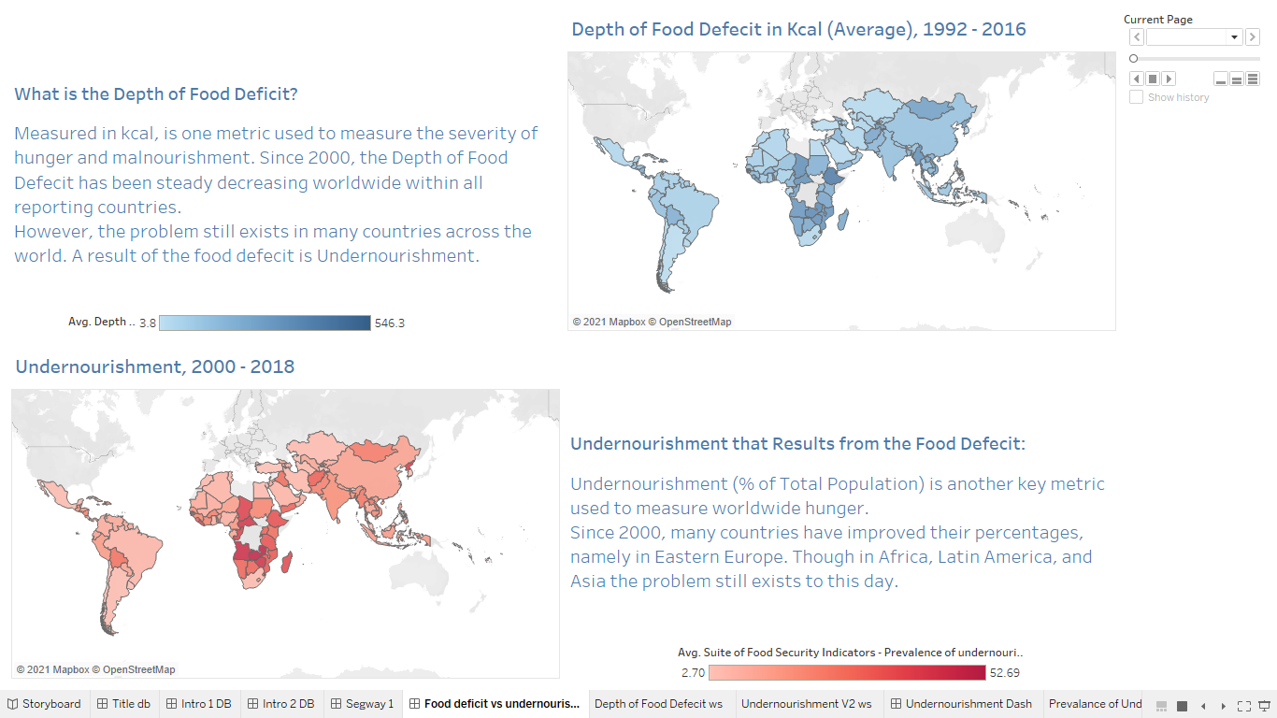

1. After I established analysis on the world level and how undernourishment has changed over the years in various countries, I decided to find the most drastic impact of undernourishment- stunting. I showed how stunting has prevailed at the world level and sensitized it with a visual depiction of the same.

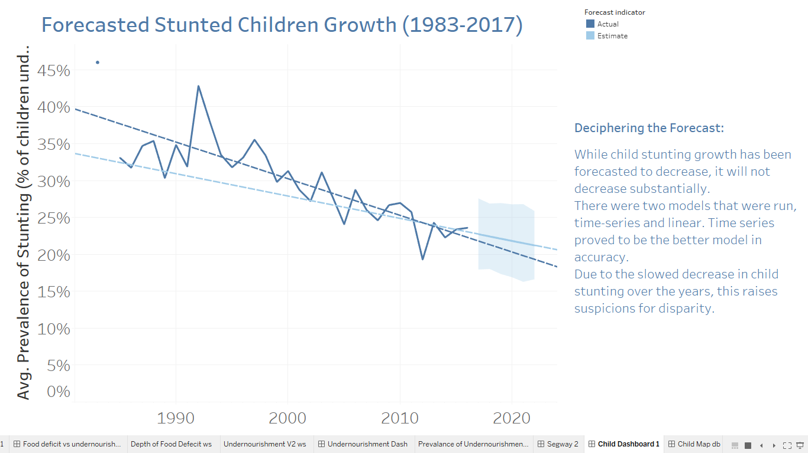

While child stunting growth was forecasted to decrease, it will not decrease substantially. There were two models that were run namely time-series and linear model. Time series proved to be the better model in accuracy.

1. Then, I had dived deeper to a country level. I showed how there are immense disparities between the most undernourished and the most affluent countries.

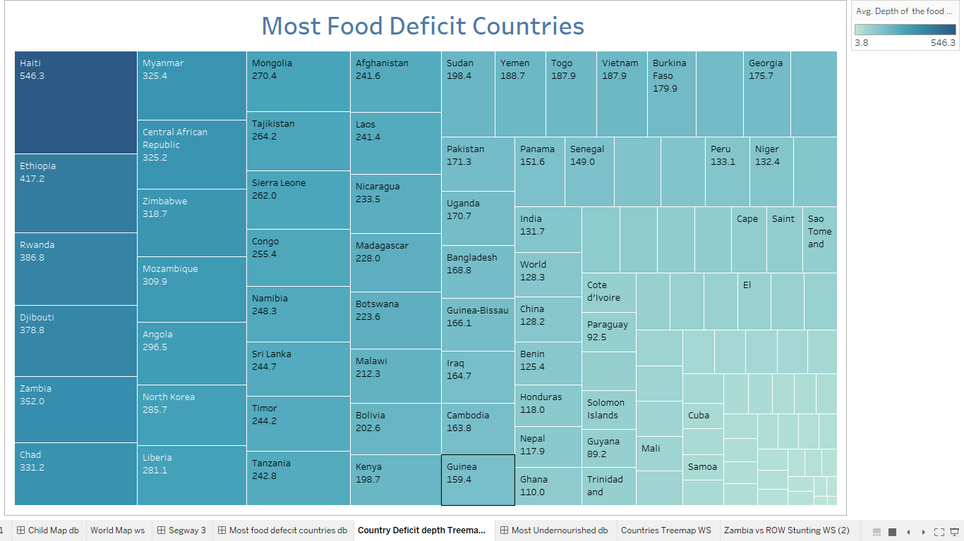

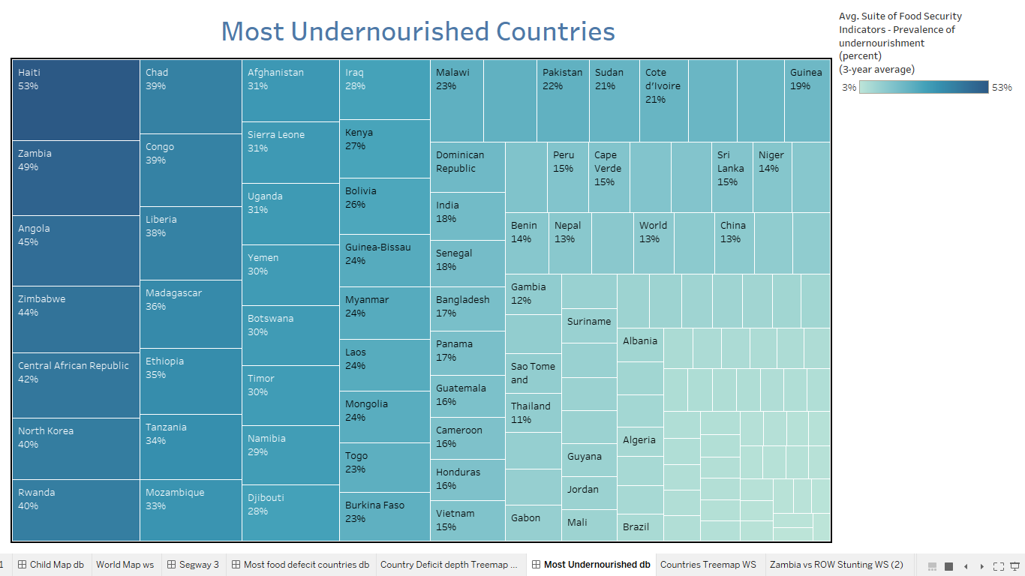

1. At last, I zeroed down to 3 specific countries to do a detailed study on. These three countries were- Zambia, Haiti, and Angola. I chose these specific countries since Zambia and Haiti were the most suffering countries with food deficit and undernourishment, while Angola was selected as it suffered undernourishment but has demonstrated a good change. I wanted to study these 3 countries to get a better idea whether there were any common reasons beyond food deficit and undernourishment in these countries, and if there were any helpful methods that can be used to tackle this problem.

Analysis of Zambia:

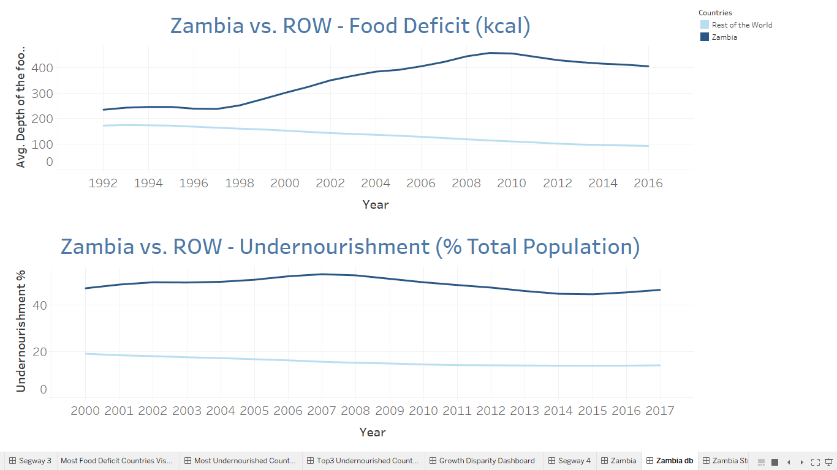

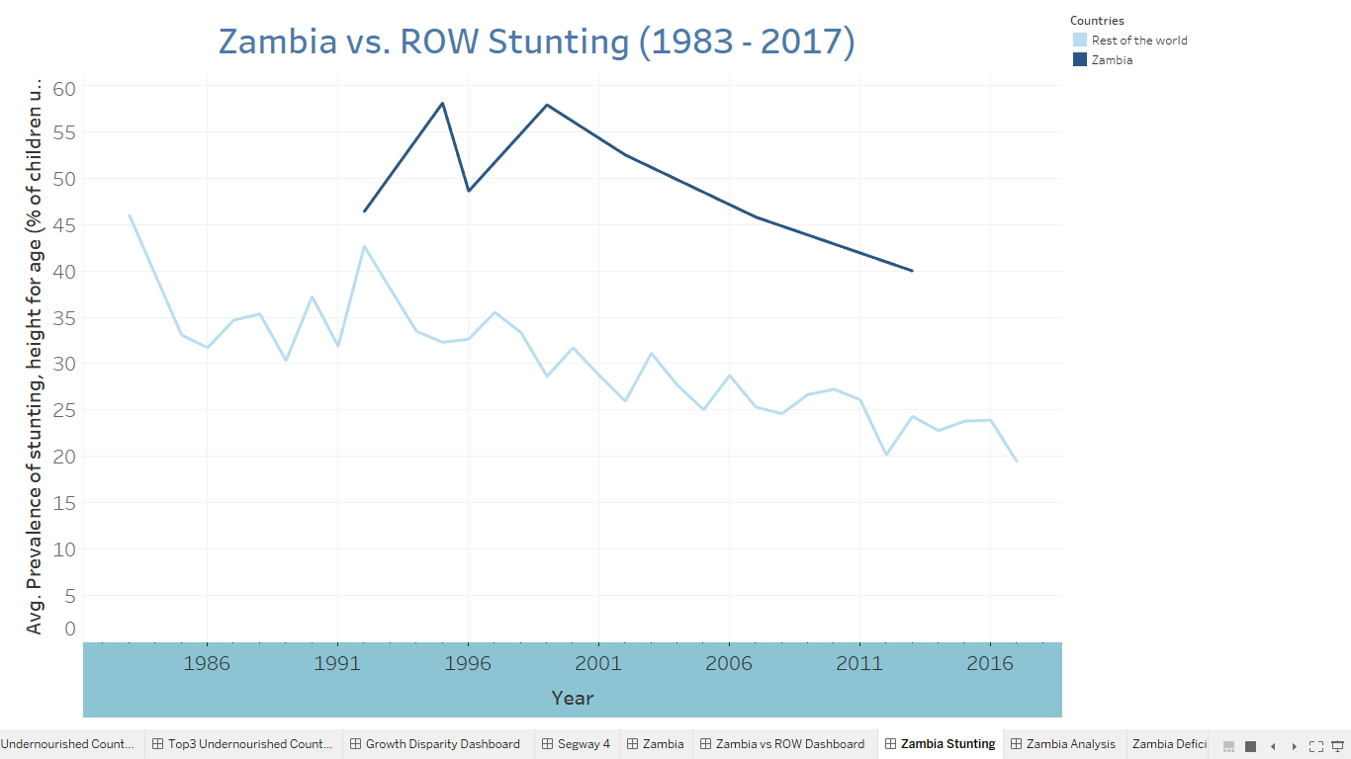

Analysis of Haiti:

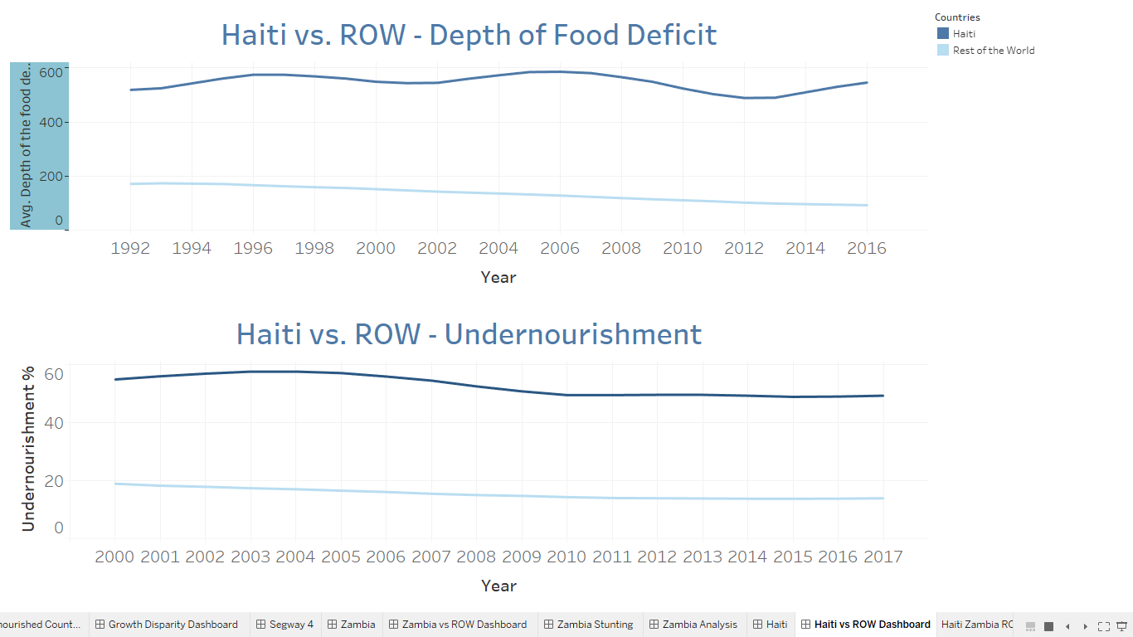

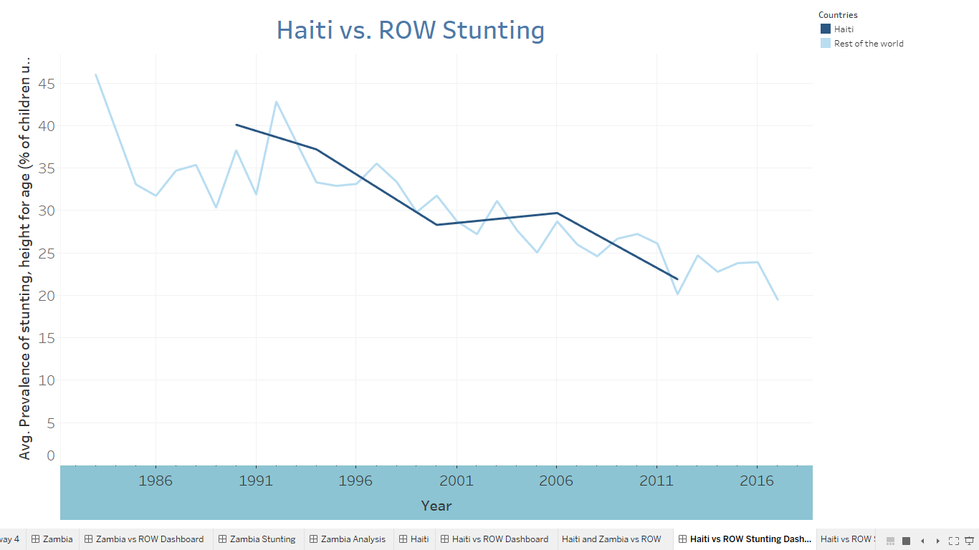

Analysis of Angola

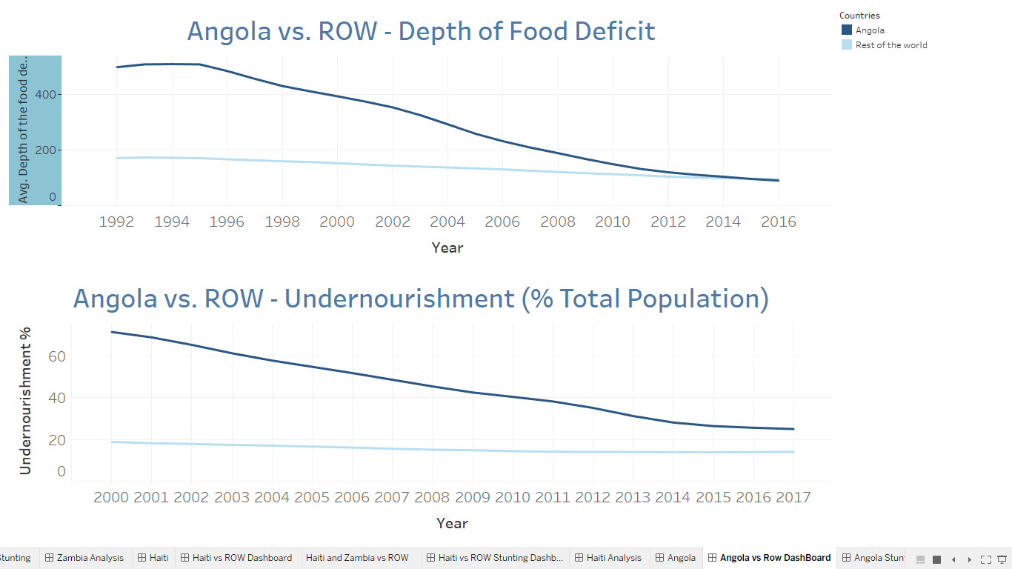

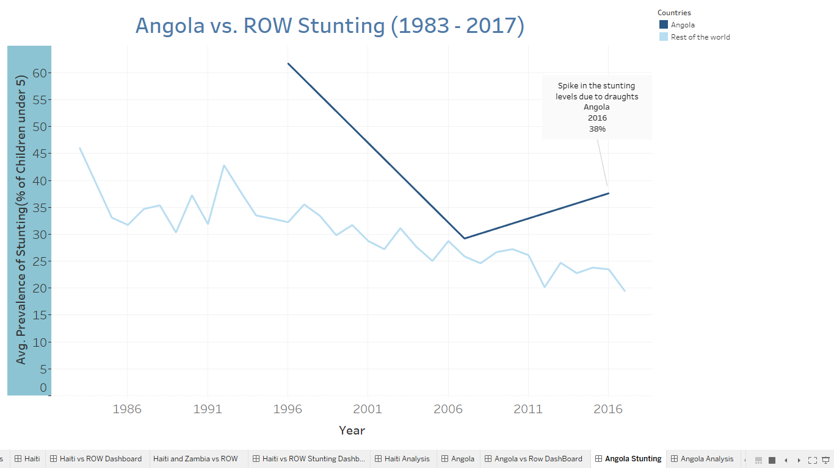

1. After the deep dive on the 3 countries, I again took a step back to share my findings regarding commonalities in the reasons and successful actions. I finally ended with a positive message of what I could do to make a dent in this grim situation for many countries, and how we have evolved over the years together and are on our way to eradicate this problem.

# **Conclusion**

After analysis of undernourishment across the world and particularly in Zambia, Haiti, and Angola, I am able to compress the entire situation in two major questions and their solutions which would decide the path forward to eradicate undernourishment around the world.

1. What initiatives have worked for fighting undernourishment:

* School feeding initiatives (United Nations WFP, JAM)
* Nutrient supplement programs (Ages 6-11 months)
* Preventative approaches / response programs (UNICEF, World Health Organization)
* Nutrition educational programs

1. What hasn’t worked in fighting Undernourishment:

* Political corruption
* Protests (gang activity, fuel shortages, political issues)
* Weather conditions (drought, floods)
* Increase of diseases
* Lack of access to sanitary water

Additional Research questions which can be answered using this project:

* The reasons behind undernourishment for countries- such as population, GDP, political instability, etc.
* Which are the top 3 and bottom 3 countries struggling with undernourishment?